**Back by popular demand –**

**Scarecrow Festival open to all in Tarves Parish**

‘Star Wars’ Theme

Scarecrow Competition

**We are looking for a scarecrow using recycled materials where possible.**

**Entry forms with competition guidelines will be available from the**

**Heritage Centre, Heritage website and Heritage Facebook**

**Registration from 16th September Display from 16th October**

**Judging week commencing 23rd October**

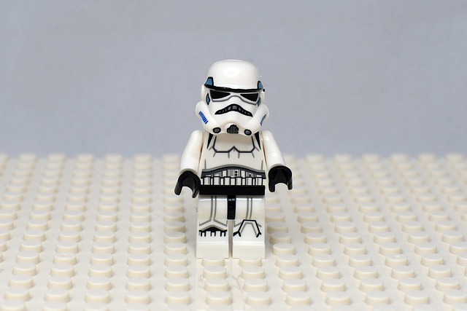

**Charity Number sc021511**